Section I: Scenario Demographics

Scenario Title: | Two for one MVC
Date of Development: | 01/03/2015 (DD/MM/YYYY)
Target Learning Group: | Juniors (PGY 1 – 2) Seniors (PGY ≥ 3) All Groups

Section II: Scenario Developers

Scenario Developer(s): | Martin Kuuskne
Affiliations/Institution(s): | McGill University
Contact E-mail (optional): | Martin.Kuuskne@gmail.com

Section III: Curriculum Integration

Learning Goals & Objectives
Educational Goal: | - To appropriately triage simultaneous patients according to severity of injury  - To downstream imaging and consultation
CRM Objectives: | To effectively communicate and lead a team through a complex situation where resources must be divided.
Medical Objectives: | 1) To recognize and decompress an acute traumatic pneumothorax  2) To recognize and manage shock in the trauma patient with initiation of blood products/MTP  3) To recognize and manage respiratory compromise in the setting of a trauma

Case Summary: Brief Summary of Case Progression and Major Events
A young male and a middle-aged female are brought to the ED after a T-bone MVC at an unknown speed. Both patients were drivers. The emergency team is expected to triage the patients accordingly and to split the team so that both patients are treated.

Patient A: The team is expected to recognize respiratory compromise secondary to pneumothorax. Needle decompression and tube thoracostomy should be administered. The patient will in remain in respiratory compromise post-decompression and the team should consider intubation. If the pneumothorax is not recognized or treated, the patient will arrest. On secondary survey, the patient will complain of pelvic pain in addition to a positive eFAST evaluation. The team should activate the massive transfusion protocol (MTP) and activate the trauma/surgery team.
Patient B: The team is expected to recognize hypoglycemia in the context of a minor head injury. Immediate glucose replacement is required.

References
Marx, J. A., Hockberger, R. S., Walls, R. M., & Adams, J. (2013). Rosen's emergency medicine: Concepts and clinical practice. St. Louis: Mosby.

Section IV: Scenario Script

A. Clinical Vignette: To Read Aloud at Beginning of Case
Before entering the room: You are working the day shift in a tertiary care emergency department with full surgical capabilities. EMS is en-route to the hospital with two patients, a 37-year-old male and a 65 year old female, who were both drivers of a t-bone MVC of unknown speed. The ambulances will arrive in 2 minutes.
Upon entering the room: Each patient will be accompanied with a paramedic who will give this information and will be available to stay if asked.
Patient A: “37 year old male, belted driver, he got t-boned on the driver’s side. There was significant intrusion of his side door. We’re not sure if there was a loss of consciousness, we put him on a non-rebreather and his SAT was around 92%, tachy at 105 with an OK BP around 110 systolic during the ride.”
Patient B: “65 year old female, belted driver who t-boned the other car. The front of her car was totaled. Airbags were deployed and there was a brief loss of consciousness. We put on the collar ASAP. Vitals were stable en route but she was a bit confused during the ride. No vomiting.”
B. Scenario Cast & Realism
Patients:  For both patients |  | Computerized Mannequin |  |  |  | Realism:  Select most important dimension(s) |  |  | Conceptual
 |  | Mannequin |  |  |  |  |  |  | Physical
 |  | Standardized Patient |  |  |  |  |  |  | Emotional/Experiential
 |  | Hybrid |  |  |  |  |  |  | Other:
 |  | Task Trainer |  |  |  |  |  |  | N/A
Confederates |  | Brief Description of Role
Two EMS attendants |  | To give the HPI and to remain to help if asked.
C. Required Monitors
EKG Leads/Wires |  |  | Temperature Probe |  |  |  | Central Venous Line
NIBP Cuff |  |  | Defibrillator Pads |  |  |  | Capnography
Pulse Oximeter |  |  | Arterial Line |  |  |  | Other:
D. Required Equipment
Gloves |  |  | Nasal Prongs |  |  |  | Scalpel
Stethoscope |  |  | Venturi Mask |  |  |  | Tube Thoracostomy Kit
Defibrillator |  |  | Non-Rebreather Mask |  |  |  | Cricothyroidotomy Kit
IV Bags/Lines |  |  | Bag Valve Mask |  |  |  | Thoracotomy Kit
IV Push Medications |  |  | Laryngoscope |  |  |  | Central Line Kit
PO Tabs |  |  | Video Assisted Laryngoscope |  |  |  | Arterial Line Kit
Blood Products |  |  | ET Tubes |  |  |  | Other:
Intraosseous Set-up |  |  | LMA |  |  |  | Other:
E. Moulage
Patient A: Clothing apparel to suit age (37 yo M). Contusion/bruise to left axilla. Board & collar.
Patient B: Clothing apparel to suit age (65 yo F). Forehead abrasions. Board & collar.
**Note: Patient B could be played by a real person if access to two computerized mannequins is limited.
F. Approximate Timing
Set-Up: | 5 min |  |  | Scenario: | 12 min |  |  | Debriefing: |  | 15 min

Section V: Patient Data and Baseline State - Patient A

A. Patient Profile and History
Patient Name: Chad |  |  |  | Age: 37 |  |  |  |  |  | Weight: 85 kg
Gender: M F |  |  |  | Code Status: Unknown
Chief Complaint: Severe diffuse pain and shortness of breath.
History of Presenting Illness: Patient was driving at unknown speed and was making a left turn when he was T-boned by another car. The driver was belted, airbags were not deployed and there was a significant intrusion on driver’s side door. Ambulance was called by bystanders.
Past Medical History: |  | Nil |  |  | Medications: |  |  |  | Nil
Allergies: Nil
Social History: unknown
Family History: unknown
Review of Systems: |  | Patient mutters about pain but unable to get focused review of systems from patient.
B. Baseline Simulator State and Physical Exam
No Monitor Display |  |  | Monitor On, no data displayed |  |  |  | Monitor on Standard Display
HR: 110/min |  | BP: 98/60 |  | RR: 25 /min |  |  | O₂SAT: 87 %
Rhythm: sinus |  | T: 36.5 ºC |  | Glucose: 6.0 mmol/L |  |  | GCS: 14 (E4 V4 M5 )
General Status: Appears unwell, increased work of breathing and in pain
CNS: | Muttering about pain, alert, moves all limbs to command
HEENT: | Normal
CVS: | Tachycardia, strong palpable pulses in all extremities
RESP: | Minimal air entry of left side. No pooling of secretions. Airway patent.
ABDO: | Normal
GU: | Normal
MSK: | Unstable pelvis. Tender with compression. |  |  |  |  | SKIN: |  | Left axillary area has contusion/bruise

Section VI: Scenario Progression –Patient A
Scenario States, Modifiers and Triggers
Patient State | Patient Status | Learner Actions, Modifiers & Triggers to Move to Next State
1. Baseline State  Rhythm: sinus tach  HR: 110/min  BP: 98 / 60  RR: 25/min  O₂SAT: 87 %  T: 36.5 ºC | GCS – 14 (E4 V6 M6) – Patient moving all 4 limbs to command.  Muttering he has pain.  Decreased air entry on left side, flail segment. | Learner Actions  - Monitor, full vitals  - Supplemental O2  - Establish IV access  - Take history from EMS  - Send trauma labs  - Needle decompression ± thoracostomy tube  - Verbalize and prepare for possible intubation  - CXR  - ± Perform eFAST  - Activate trauma team | Modifiers  Changes to patient condition based on learner action  - Needle decompression or finger thoracostomy rush of air  - eFAST NO lung sliding on left  Triggers  For progression to next state  - No decompression or thoracostomy by 3 min  2. Worsening  - Needle decompression 3. Brief Improvement
2. Worsening  HR: 120 bpm  BP: 88/50  RR: 30 /min  O₂SAT: 78 % | Increased respiratory distress. | Learner Actions  - Needle decompression ± thoracostomy tube  -Performs eFAST if not already done so  - Verbalize & prepare for intubation if not already done so | Modifiers  - If no decompression in 2 min, RN to cue  Triggers  - Needle decompression 3. Brief Improvement
3. Brief Improvement  HR: 100  BP: 95/55  RR: 20  O₂SAT: 91% | Decreased respiratory distress but ongoing flail segment | Learner Actions  - Secondary Survey performed  - Prepare for intubation  - Thoracostomy tube  - Perform FAST  - Pelvic xray | Modifiers  - FAST shows FF RUQ  - PXR: open book #  Triggers  - 2 min into state 4. Repeated Hypotension
4. Repeated Hypotension  HR: 115  BP: 75/35  RR: 18  O₂SAT: 89% | Unchanged | Learner Actions  - Order blood products/initiate massive transfusion protocol  - Wrap pelvis  - Prepare for intubation  - Intubation | Triggers  - 2 units PRBC given  5. Improvement
5. Improvement  HR: 95  BP: 115/75  RR: 12 (vent)  O₂SAT: 92% | Unchanged | Learner Actions  - Call general surgery or ortho for OR or arrange for CT angio/interventional OR  - Intubation (if not yet)  - Positive Pressure Ventilation  - Post-intubation xray  - Initiate sedation | Triggers  END CASE PRN
Section VII: Supporting Documents, Laboratory Results, & Multimedia – Patient A

Laboratory Results – Patient A
Na: 130 |  | K: 4.5 |  | Cl: 105 |  | HCO₃: 21
VBG | pH: 7.21 |  | PCO₂: 30 | PO₂: 40 | HCO₃: 21 |  | Lactate: 3.0
WBC: 14 |  |  | Hg: 135 |  | Plt: 250
INR: 1.1 |  |  |  | PTT: 24.5

Images (ECGs, CXRs, etc.)
Patient A – Supine CXR  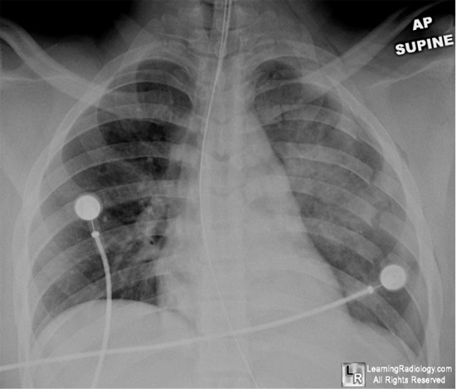  CXR source: http://learningradiology.com/archives2009/COW%20353-Flail%20Chest/caseoftheweek353page.htm | Patient A – Pelvic Xray  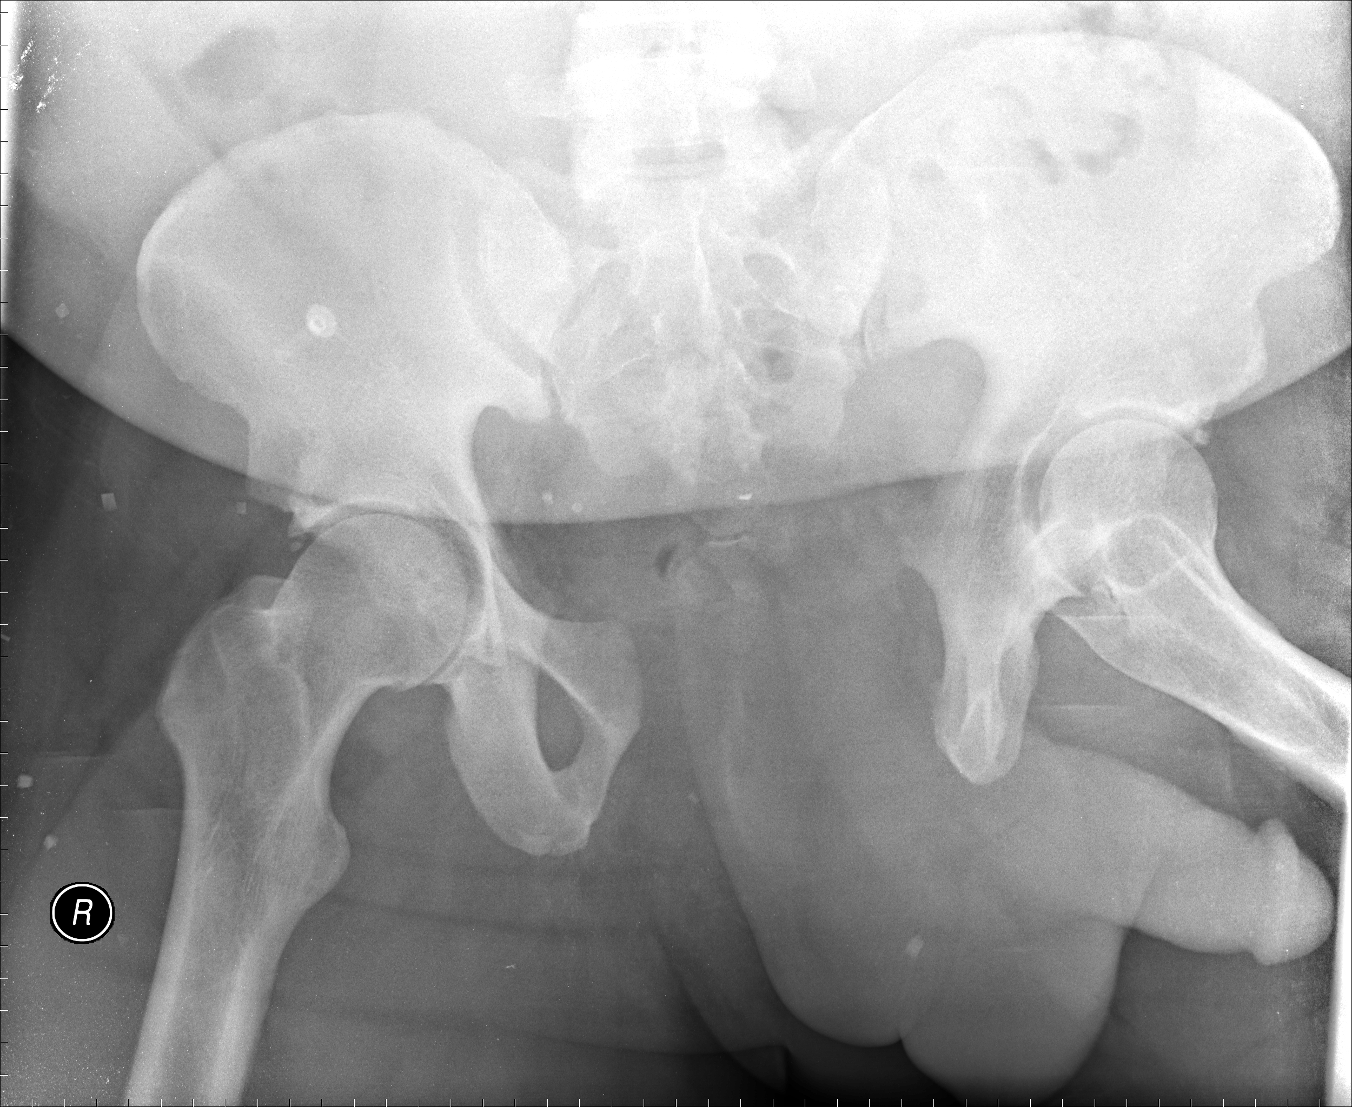  XR source: http://radiopaedia.org/articles/open-book-fracture
Ultrasound Video Files (if applicable)
No lung sliding | FAST: Free fluid RUQ
No pericardial effusion

Section VIII: Patient Data and Baseline State - Patient B

A. Patient Profile and History
Patient Name: Michelle Bissidy |  |  |  |  |  | Age: 65 |  |  |  |  |  |  |  | Weight: 75kg
Gender: M F |  |  |  |  |  | Code Status: Unknown
Chief Complaint: Head injury
History of Presenting Illness: Patient drove into another car at an unknown speed. Patient was belted and airbags deployed. Brief loss of consciousness noted by EMS. Vitals stable and patient collared.
Past Medical History: |  | Hypertension |  |  |  |  | Medications: |  |  |  |  | Hydrochlorothiazide
 |  | Dyslipidemia |  |  |  |  |  |  |  |  |  | Atorvastatin
 |  | Diabetes |  |  |  |  |  |  |  |  |  | Metformin
 |  |  |  |  |  |  |  |  |  |  |  | Insulin
Allergies: nil
Social History: unknown
Review of Systems: |  | CNS: |  |  | Complaining of mild headache.
 |  | HEENT: |  |  | No complaints.
 |  | CVS: |  |  | No complaints.
 |  | RESP: |  |  | No complaints.
 |  | GI: |  |  | No complaints.
 |  | GU: |  |  | No complaints.
 |  | MSK: |  |  | No complaints. |  |  |  |  |  |  |  | INT: |  | No complaints.
B. Baseline Simulator State and Physical Exam
No Monitor Display |  |  |  | Monitor On, no data displayed |  |  |  |  |  |  | Monitor on Standard Display
HR: 90 /min |  |  | BP: 110/78 |  |  |  |  | RR: 18/min |  |  |  |  |  |  | O₂SAT: 99%
Rhythm: sinus |  |  | T: 35.6ºC |  |  |  |  | Glucose: 2.6 mmol/L |  |  |  |  |  |  | GCS: 12 (E3 V4 M5)
General Status: Appears well.
CNS: | Seems confused. Somewhat agitated. Responding to pain, but not obeying commands.
HEENT: | Normal
CVS: | Palpable, strong, tachycardic, pulse in all extremities. No murmurs. Normal heart sounds
RESP: | GAEB, no adventitious sounds
ABDO: | Normal
GU: | Normal
MSK: | No extremity deformities |  |  |  |  |  |  |  | SKIN: | Forehead abrasions

Section IX: Scenario Progression –Patient B
Scenario States, Modifiers and Triggers
Patient State | Patient Status | Learner Actions, Modifiers & Triggers to Move to Next State
1. Baseline State  Rhythm: NSR  HR: 90/min  BP: 110/78  RR: 18/min  O₂SAT: 99 %  T: 35.6ºC | GCS – 12  Seems confused. Responds to pain, but not obeying commands. Patient is collared. | Learner Actions  - Monitor, full vitals  - Establish IV access  - Take history from EMS  - Perform primary survey  - Check cap sugar: 2.6 mmol/L  - Replace glucose with D50  - Send trauma labs  - ± eFAST  - Progress to secondary survey  - Determine need for further imaging (CT head, C-spine films) | Modifiers  Changes to patient condition based on learner action  -If patient not assessed Patient becomes more agitated  - If eFAST done negative  - If team decides needs imaging radiology will ask who to image first  Triggers  For progression to next state  - If cap sugar not checked by 5 min 2. Decreased LOC  - If sugar replaced, primary and secondary survey complete  3. Normal GCS
2. Decreased LOC  HR: 100  BP: 120/75  RR: 12 | GCS to 7.  E1 V2 M4  Patient essentially unresponsive | Learner Actions  - Check cap sugar: 2.6 mmol/L  - Replace glucose with D50  - Arrange for CT head  - Consider other causes of aLOC | Modifiers  - If preparing to intubate, RN to ask: “should we check a sugar first?”  Triggers  - Glucose replaced 3. Normal GCS
3. Normal GCS  HR: 90/min  BP: 110/78  RR: 18/min  O₂SAT: 99 % | GCS 15  Patient alert and oriented | Learner Actions  - Send trauma labs  - ± eFAST  - Progress to secondary survey  - Determine need for further imaging (CT head, C-spine films) | END CASE PRN

Section X: Supporting Documents, Laboratory Results, & Multimedia – Patient A & B

Laboratory Results - Patient B
Na: 140 |  | K: 3.9 |  | Cl: 108 |  | HCO₃: 22
VBG | pH: 7.35 |  | PCO₂: 40 | PO₂: | HCO₃: 21 |  | Lactate:1.1
WBC: 11 |  |  | Hg: 110 |  | Plt: 350
INR: 1.0 |  |  |  | PTT: 26.5
Images (ECGs, CXRs, etc.)
Patient B – CXR
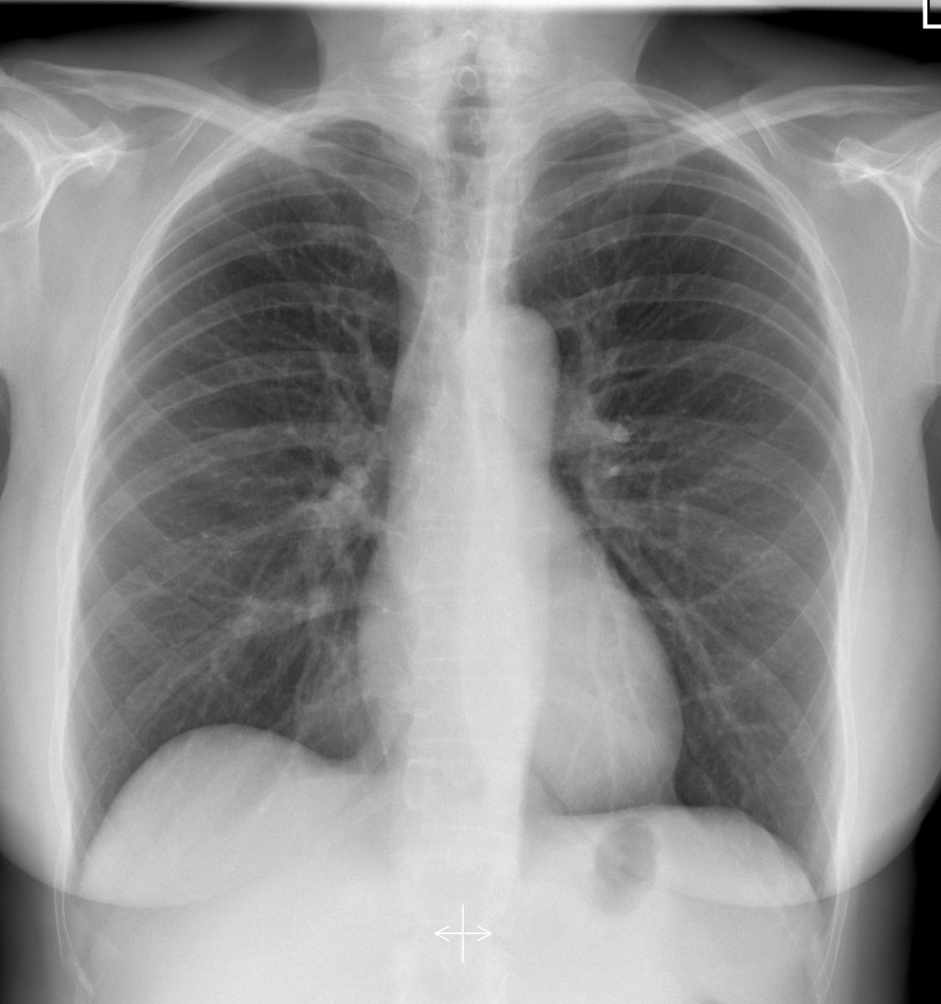
CXR source: http://radiopaedia.org/articles/normal-position-of-diaphragms-on-chest-radiography

Section XI: Debriefing Guide

General Debriefing Plan
Individual | Group |  | With Video | Without Video
Objectives
Educational Goal: |  | 1) To appropriately triage simultaneous patients according to severity of injury  2) To downstream imaging and consultation
CRM Objectives: |  | To effectively communicate and lead a team through a complex situation where resources must be divided.
Medical Objectives: |  | 1) To recognize and decompress an acute traumatic pneumothorax  2) To recognize and manage shock in the trauma patient with initiation of blood products/MTP  3) To recognize and manage respiratory compromise in the setting of a trauma
Sample Questions for Debriefing
- How was the decision made to split the team and resources? Do you think it was done well?
- What was the team leader’s leadership style? To oversee both traumas or to lead one case and assign a team member to lead the other case?
- What difficulties are faced when using resources for a trauma involving multiple patients?
- What is the appropriate treatment for flail chest?
- How does the management of pelvic fractures change depending on patient stability?
Key Moments
Recognition that the team must be split to appropriately manage both patients.
Triaging the patients.
Recognition that Patient A continued to deteriorate despite the needle decompression/tube thoracostomy.

